**PROJECT “PHOENIX”**

Inside Out + Binding of Isaac + Transistor + Diablo 3. An Isometric RPG representing my mind and experiences. Symbol of redemption and coming back from the dead. Empathy machine.

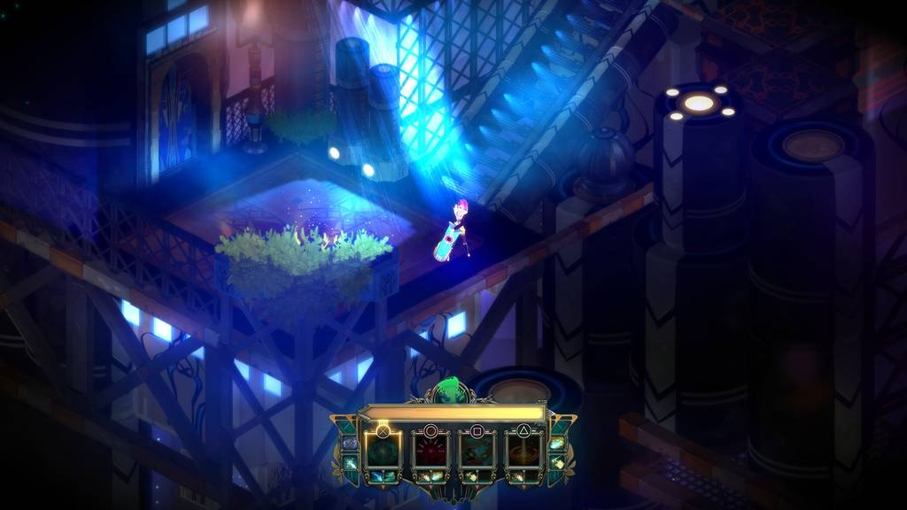 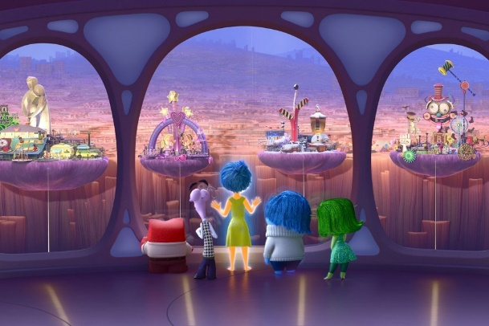

Genre: RPG, 3rd person fixed camera RPG  
Target Audience: R for Restricted

Controls: Mouse and Keyboard

Thematic Setting: My mind

Tech Stack: Unity 5+, Blender, Gimp, Audacity

Platform(s): Steam

Game Moment:  Attacking mental creatures in a section of my mind with psychic abilities

Game Summary: A person’s soul explores their own mind and memory. Monsters are represented by mythological creatures, and the hero uses a soul-powered bow (or staff? Or just magic/psychic abilities through hands?) to fight off their own weaknesses. Exploring the mind of Joey and its ups and downs.

Core Player Experience: Dark, Internal Conflict, Poignant

Central Theme: Mental Health and the Soul

Design Pillar: Make the player feel the struggle of mental health and overcoming vices, but also the rewards of pushing through.

Anticipated Remarkability: How it makes people feel and empathize

Anticipated Steam Early Access Launch date: Q3 2018

Feature Development Priorities:

- Combat with different enemies

- Symbolism and poignancy in story, level design, and dialogue

- RPG abilities and stats

Comparative Products:

- Diablo 3

- Psychonauts

- Binding of Isaac

- Inside Out

- Transistor

What would it be like to inside my mind?

Art Style:

- Simple, abstract, symbolic, and purposeful

- Silhouettes, shadows, and concepts

- Cloudy and misty mysteriousness mixed with struggle

- Minimal dialogue

White and black are the main enemies

Colour is most friendly/good things

Simple ranged attacks that can be modified

More complex charged up RMB ranged attacks

No held weapons

**Project “Name”   
Art Direction Concept Document**

Philosophy of this particular Art Direction:

* Dark, mysterious, and moody. Player should feel like they are uncovering new parts of a person’s mind.
* Describe how the player interacts with the environment. For example, the camera will be zoomed out so everything needs to be exaggerated or the game is 1st person camera so textures need to be high detail.
* Moody and mysterious abstract mindscape
* Representations of both extremely positive and negative experiences. An example would be “coming out” and revealing oneself to close friends and family represented by a rainbow level, versus a dark and black depressed nothingness level, and a blinding white optimistic level

Summary of Art Direction

This camera, lighting, perspective, overall feel....



|  |  |  |
| --- | --- | --- |
|  | |  |
|  |  |

With these images of characters, enemies, people, monsters…

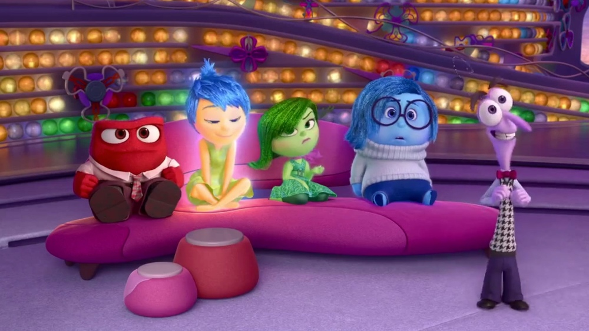

In these settings / locations…

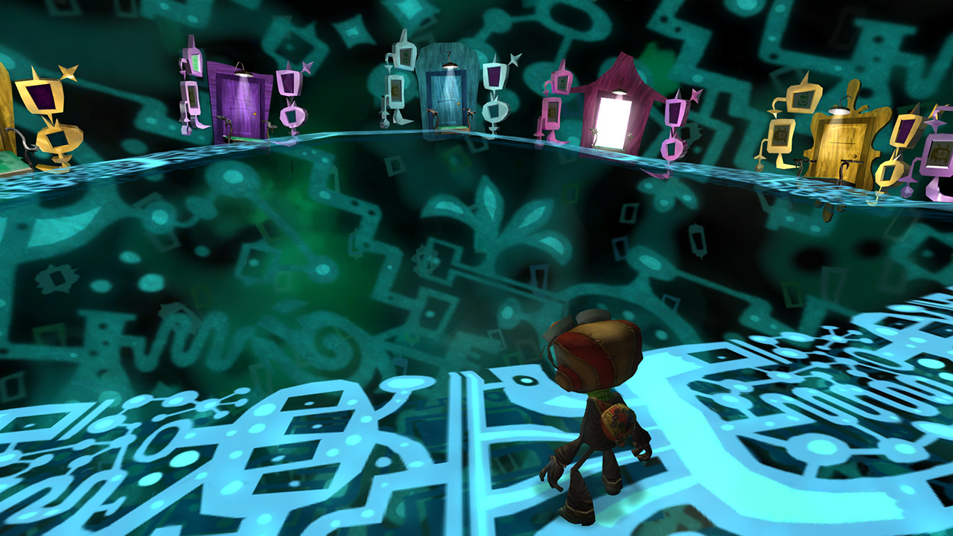

With this sort of polish / effects…

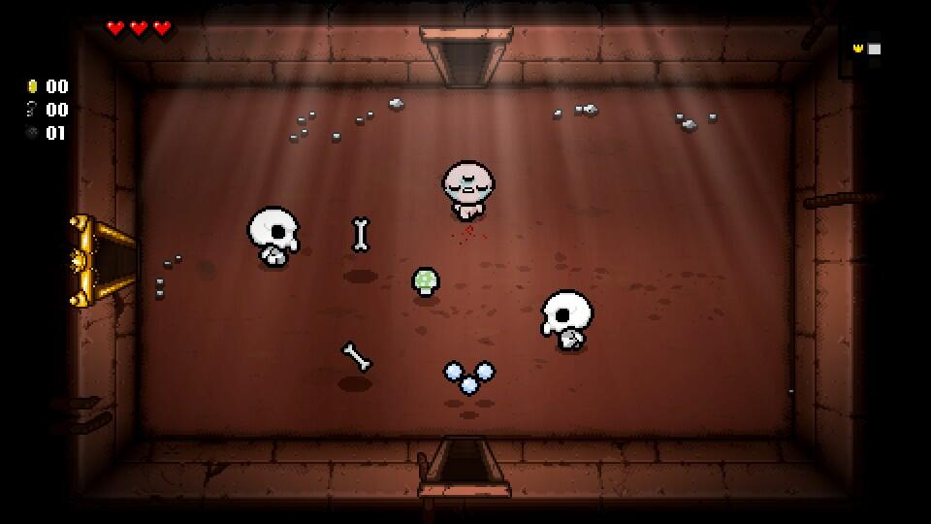

With this type of colour palette…

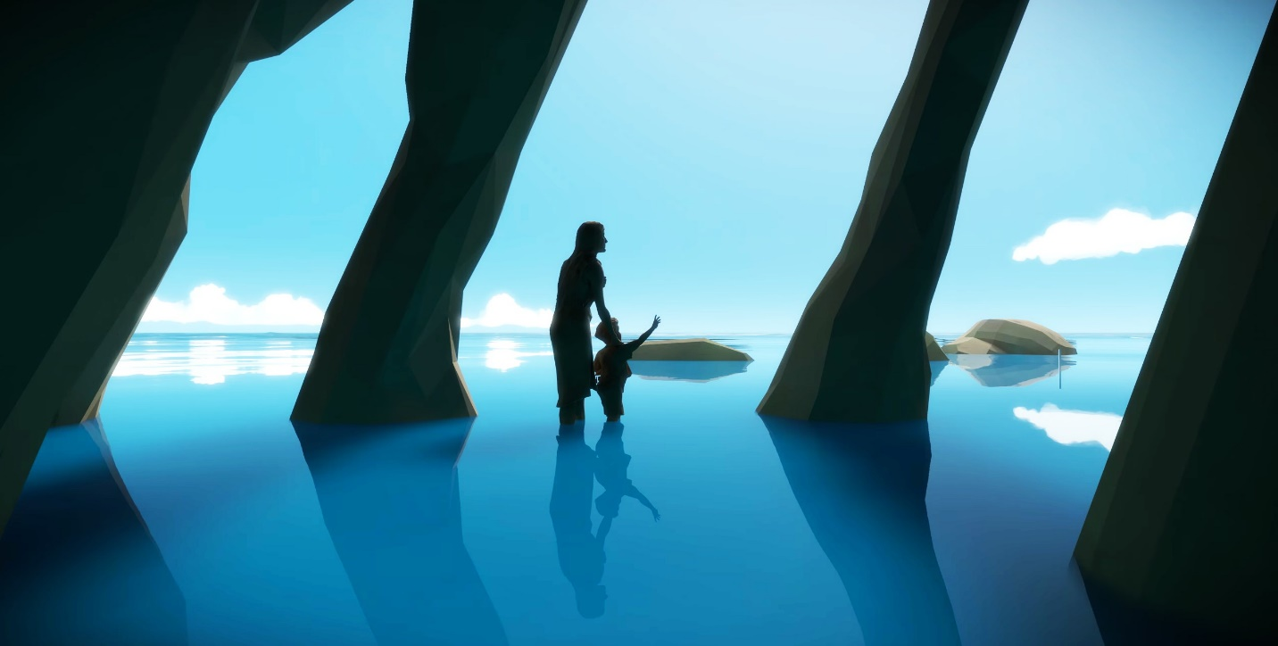

More Detailed Explanation

If useful, go through some of the images you that found and particularly liked, highlighting what aspects you like. Eg. the shape of a building, the clothes of a character, the lighting of a room and so on.

You might have 3 images in this section, you might have 30 - put in as many as is useful to yourself or to an artist who might be working on the project with you.